Phân trang

Trong HomeController

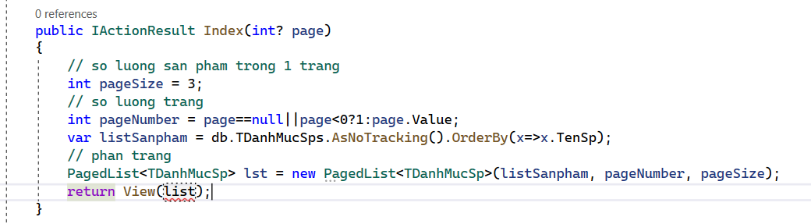

public IActionResult Index(int? page)

{

// so luong san pham trong 1 trang

int pageSize = 3;

// so luong trang

int pageNumber = page==null||page<0?1:page.Value;

var listSanpham = db.TDanhMucSps.AsNoTracking().OrderBy(x=>x.TenSp);

// phan trang

PagedList<TDanhMucSp> list = new PagedList<TDanhMucSp>(listSanpham, pageNumber, pageSize);

return View(list);

}

Go to View

Thêm: @using X.PagedList.Mvc.Core;

Sửa Model: @model X.PagedList.IPagedList<TDanhMucSp>

Thêm :

<div class="product__pagination">

@Html.PagedListPager(Model, page=>Url.Action("Index", new {page=page}))

</div>

</div>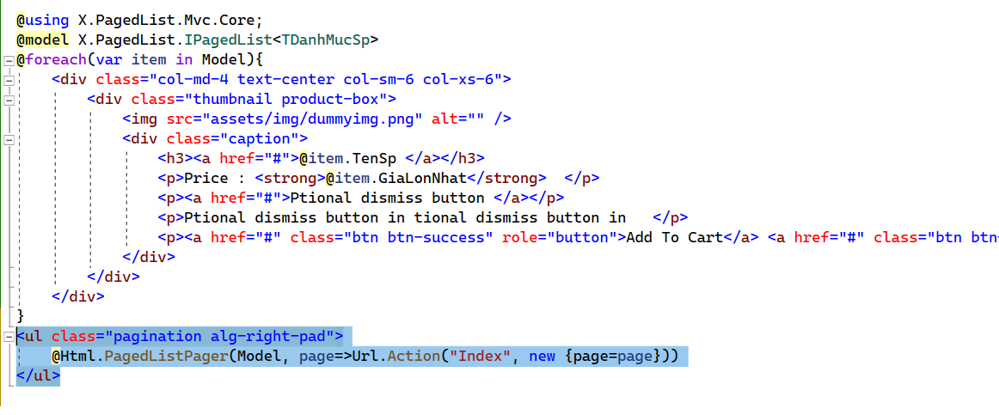

**Tạo dynamic menu bằng Component**

Tao folder moi:

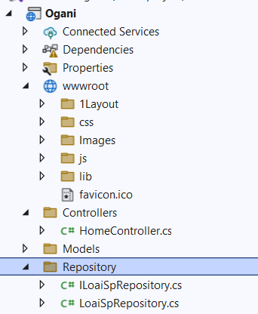

Add class -> interface: ILoaiSpRepository:

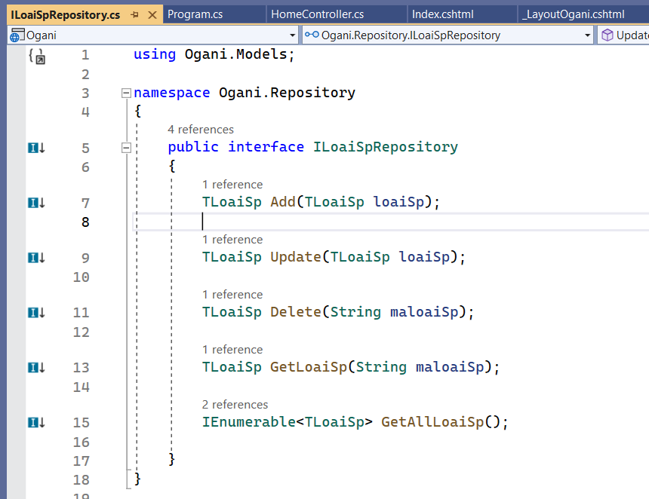

using Ogani.Models;

namespace Ogani.Repository

{

public interface ILoaiSpRepository

{

TLoaiSp Add(TLoaiSp loaiSp);

TLoaiSp Update(TLoaiSp loaiSp);

TLoaiSp Delete(String maloaiSp);

TLoaiSp GetLoaiSp(String maloaiSp);

IEnumerable<TLoaiSp> GetAllLoaiSp();

}

}

**Them class LoaiSpRepository:**

public class LoaiSpRepository : ILoaiSpRepository

{

private readonly QlbanVaLiContext _context;

public LoaiSpRepository(QlbanVaLiContext context)

{

_context = context;

}

public TLoaiSp Add(TLoaiSp loaiSp)

{

_context.TLoaiSps.Add(loaiSp);

_context.SaveChanges();

return loaiSp;

}

public TLoaiSp Delete(string maloaiSp)

{

throw new NotImplementedException();

}

public IEnumerable<TLoaiSp> GetAllLoaiSp()

{

return _context.TLoaiSps;

}

public TLoaiSp GetLoaiSp(string maloaiSp)

{

return _context.TLoaiSps.Find(maloaiSp);

}

public TLoaiSp Update(TLoaiSp loaiSp)

{

_context.Update(loaiSp);

_context.SaveChanges();

return loaiSp;

}

}

**Tao folder moi ViewComponents**

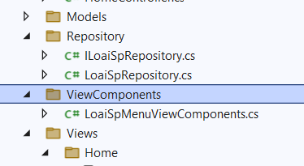

using Microsoft.AspNetCore.Mvc;

using Ogani.Repository;

namespace Ogani.ViewComponents

{

public class LoaiSpMenuViewComponent : ViewComponent

{

private readonly ILoaiSpRepository _loaiSp;

public LoaiSpMenuViewComponent(ILoaiSpRepository loaiSpRepository)

{

_loaiSp = loaiSpRepository;

}

public IViewComponentResult Invoke()

{

var AllLoaiSp = _loaiSp.GetAllLoaiSp().OrderBy(x => x.Loai);

return View(AllLoaiSp);

}

}

}

Trong Shared tạo 1 folder Components -> Folder HangSxMenu -> View Default:

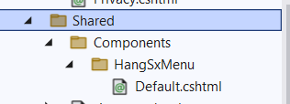

Thay the Menu cua trang (tim doan code phan Menu)

Them: @await Component.InvokeAsync("LoaiSpMenu")

**LoaiSp:**

@model IEnumerable<TLoaiSp>

<div class="col-lg-3">

<div class="hero__categories">

<div class="hero__categories__all">

<i class="fa fa-bars"></i>

<span>All departments</span>

</div>

<ul>

@foreach (var item in Model)

{

<li><a href="">@item.Loai</a></li>

}

</ul>

</div>

</div>

Vao Program them:

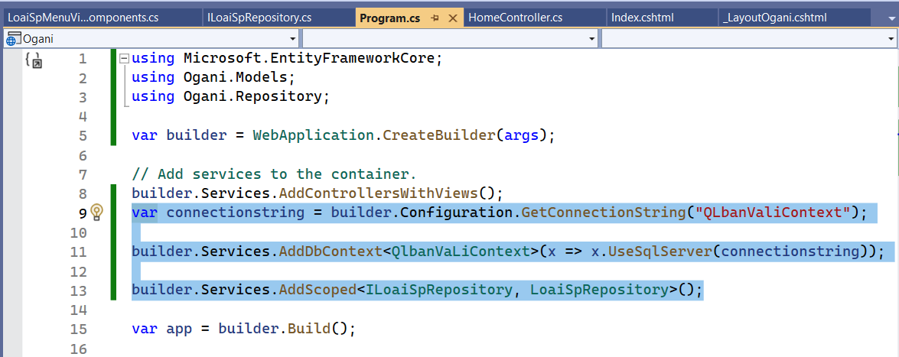

Code:

var connectionstring = builder.Configuration.GetConnectionString("QLbanValiContext");

builder.Services.AddDbContext<QlbanVaLiContext>(x => x.UseSqlServer(connectionstring));

builder.Services.AddScoped<ILoaiSpRepository, LoaiSpRepository>();